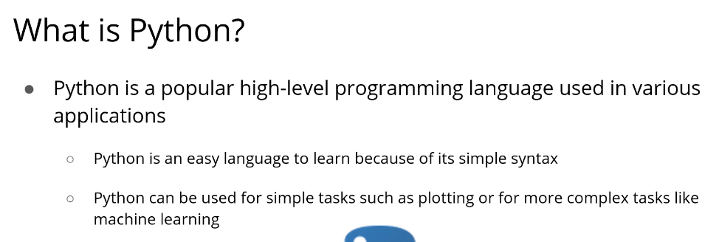

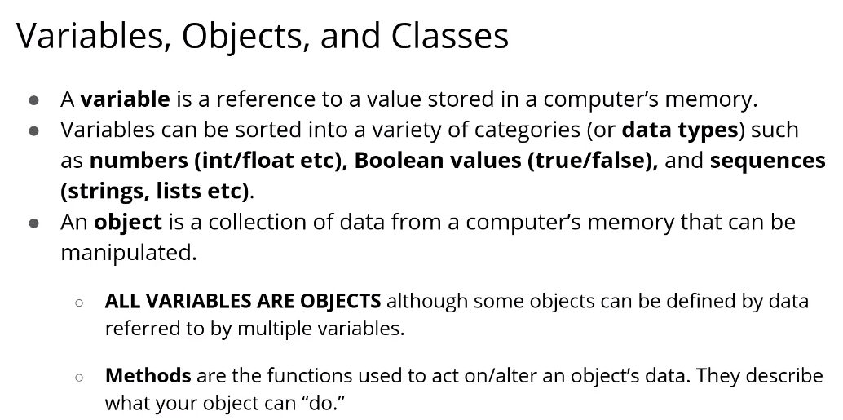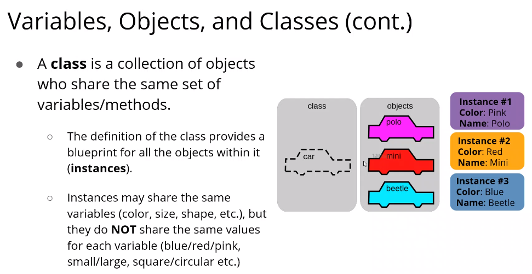

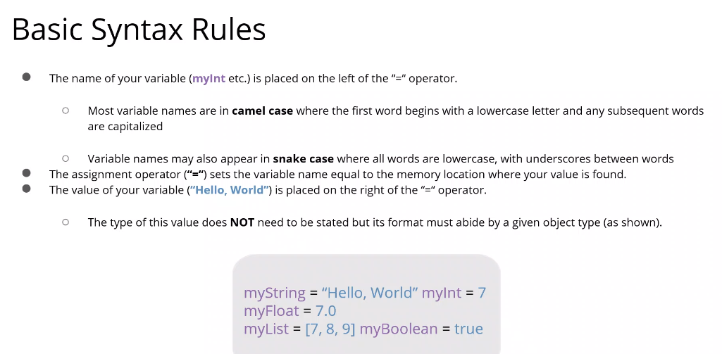

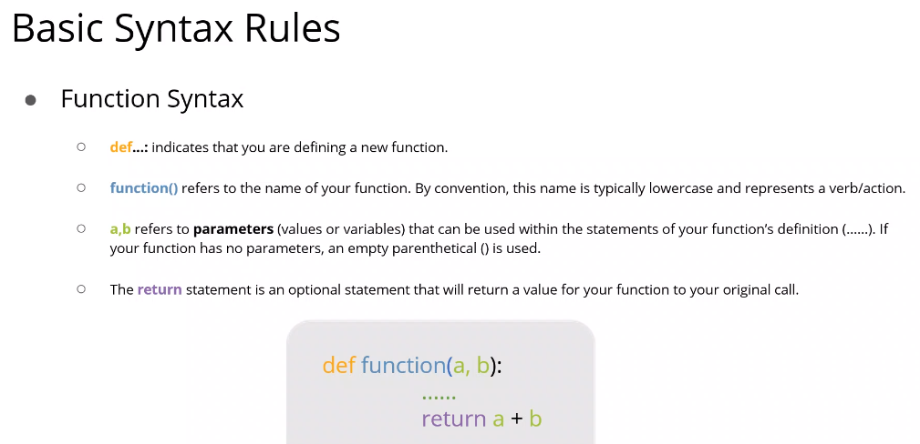

STRINGS

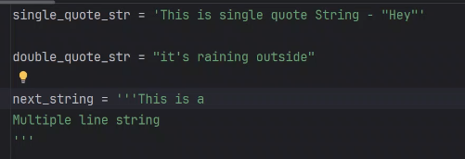

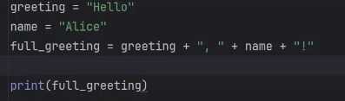

* Appending string ^

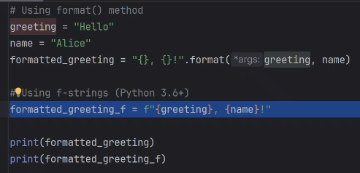

* Using Format method ^

STRING OPERATIONS

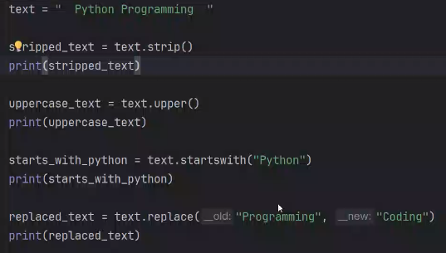

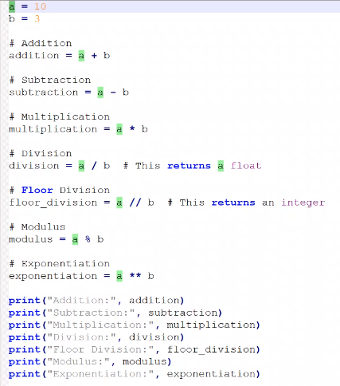

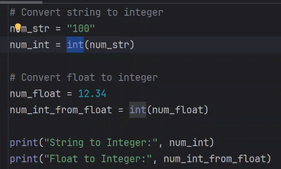

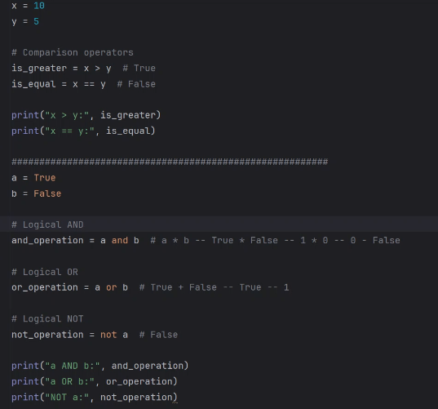

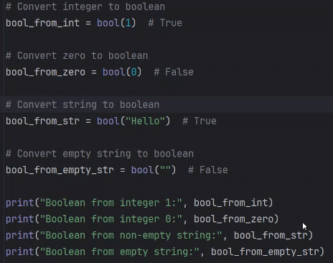

* Bool of 0 IS FLASE and bool of all other numbers are true
* Bool of String is True and BOOL of Empty string is False ^

LISTS

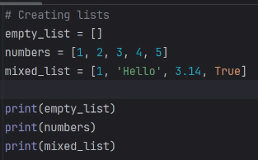

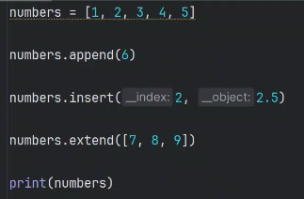

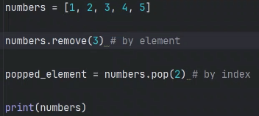

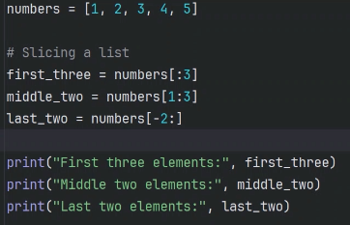

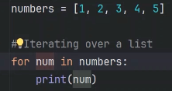

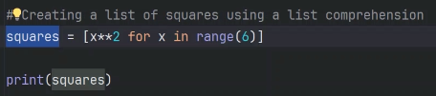

DICTIONARY

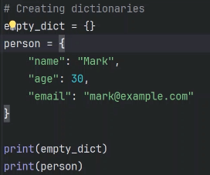

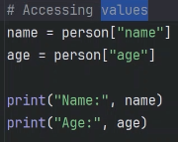

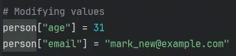

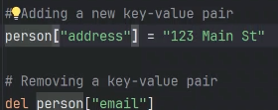

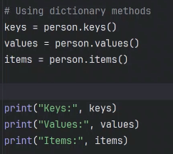

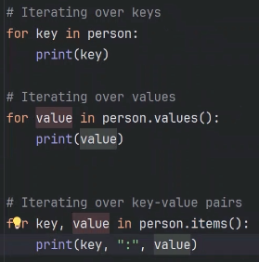

***TUPLES***

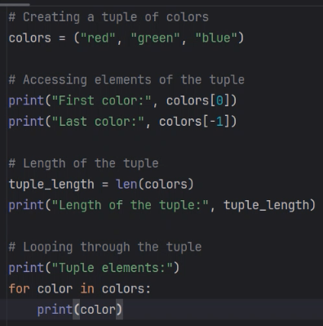

* Tuples are immutable ,cant add or remove elemets once it is assigned

***SETS***

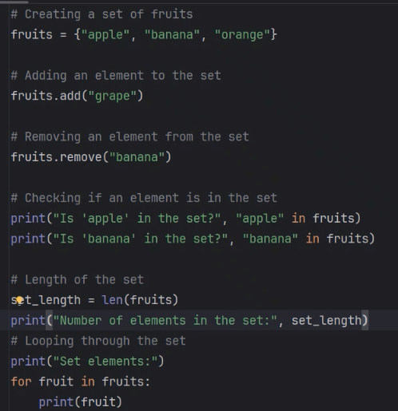

* Sets are mutable and it is unordered

LIST OF DICTIONARIES

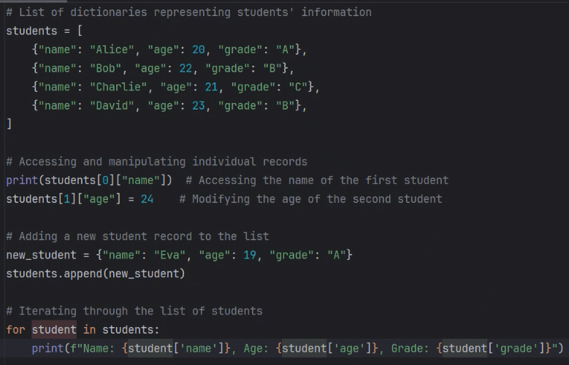

**OOPS [OBJECT ORIENTED PROGRAMMING]**

* Class is the blueprint of the object
* Object is the instance of the class which creates memory space for the code (in ram)
* Self is used to refer the object within the class (self is the object of the class)

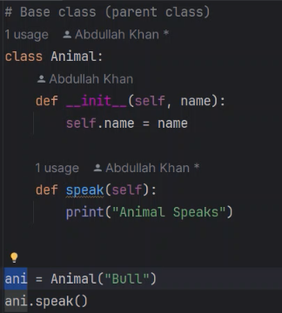

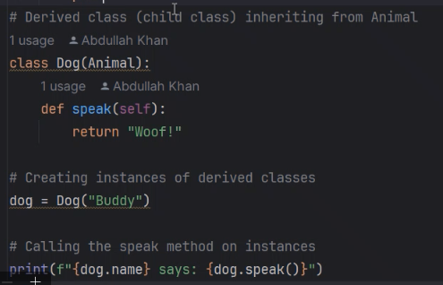

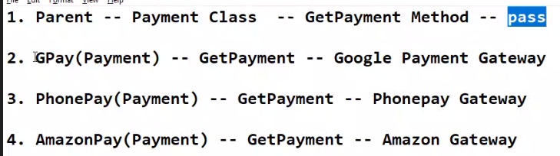

* **Inheritance** – other classes will inherit from main class ^

**FILES**

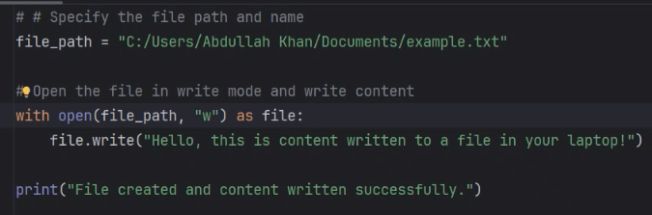

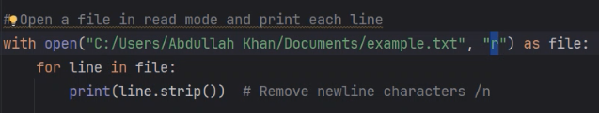

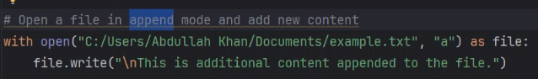

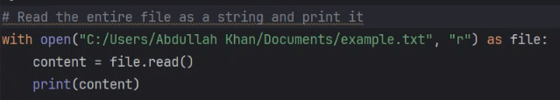

**CSV (Comma Separated Values)**

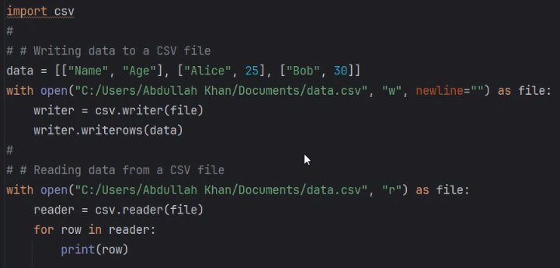

**JSON Files**

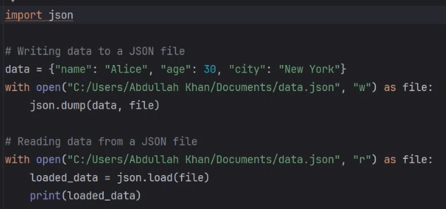

***API (Application Programming Interface )***

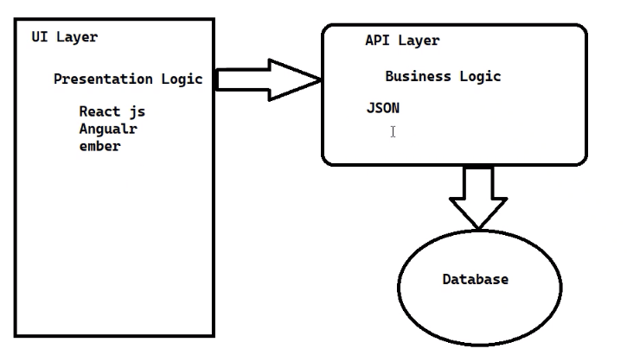

* Example for API : Weather report , Cricket scorecard,Google maps

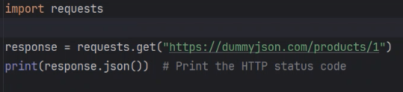

***PANDAS***

* It helps you to manipulate the data

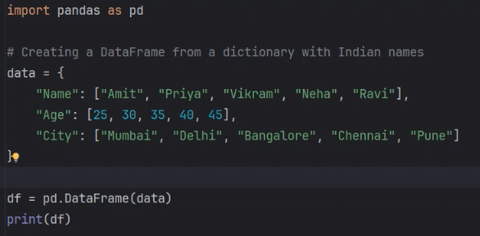

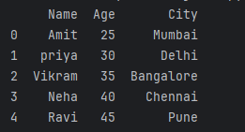

Output

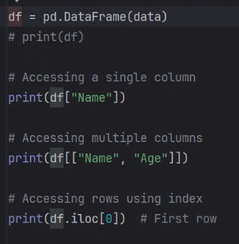

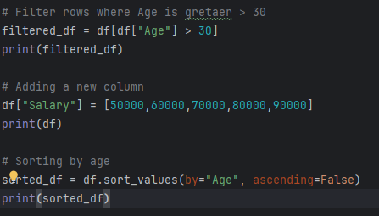

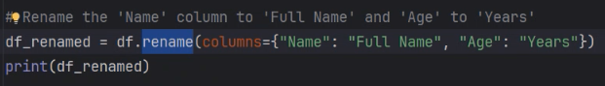

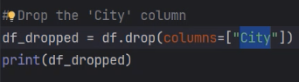

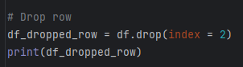

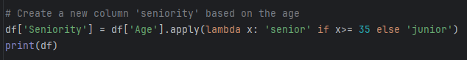

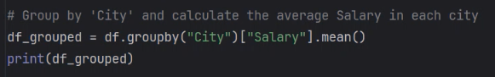

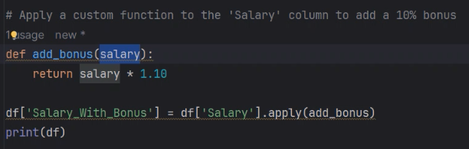

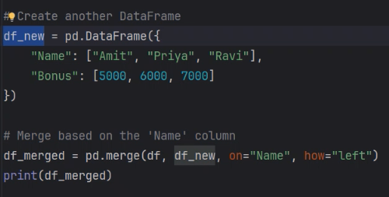

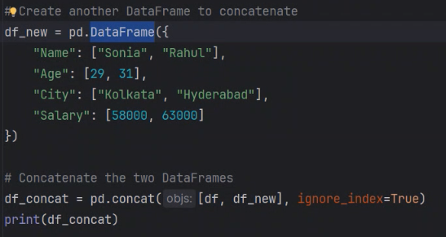

To read data from csv [Pandas – CSV ]

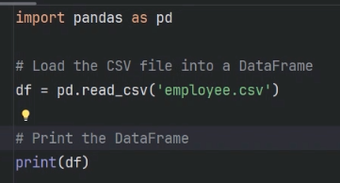

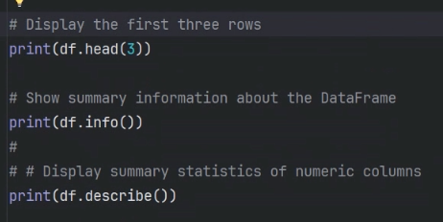

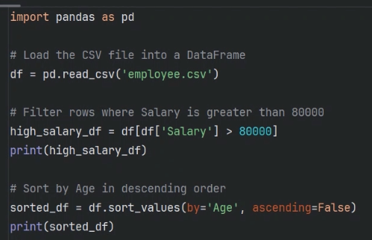

Reading JSON Using Pandas

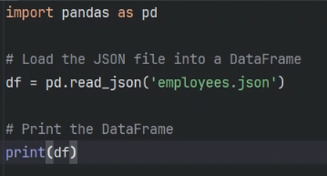

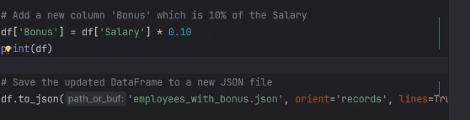

***MODULES***

* When we create a function directly ,then it is treated as modules
* Wwe can import it and use it

Creating a module :

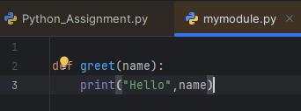

Importing a module:

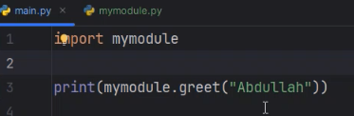

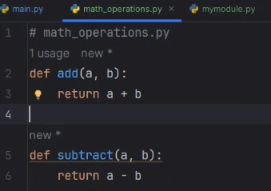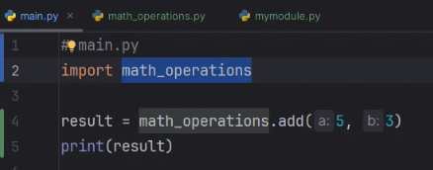

Example for modules and importing

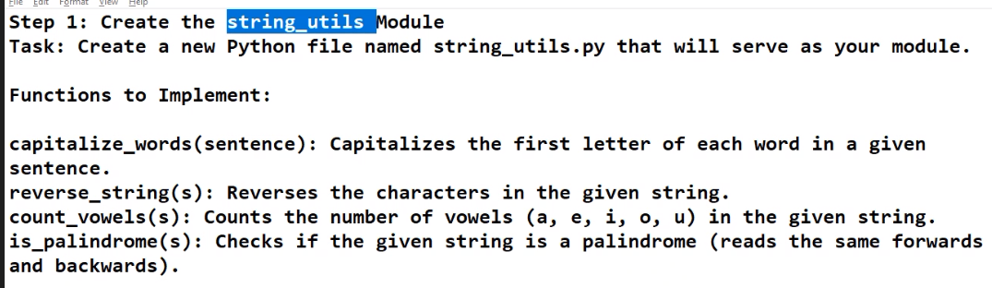

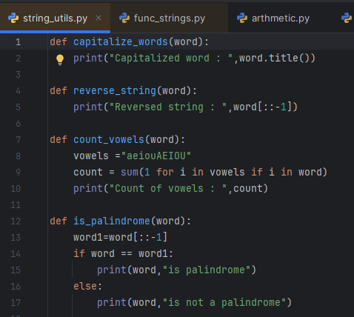

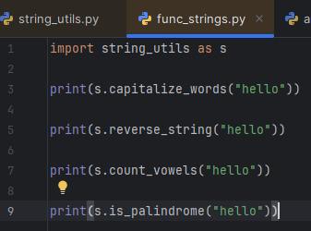

RUNNING MODULE AS A SCRIT

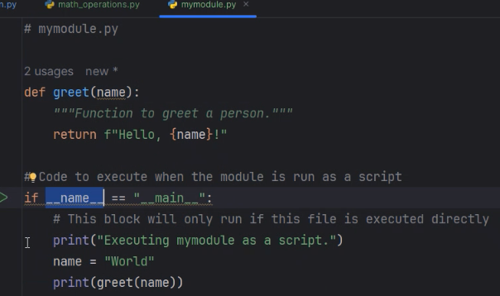

* It will execute only when it is in the main file.it will not work in the imported file

MODULES INSIDE PACKAGE

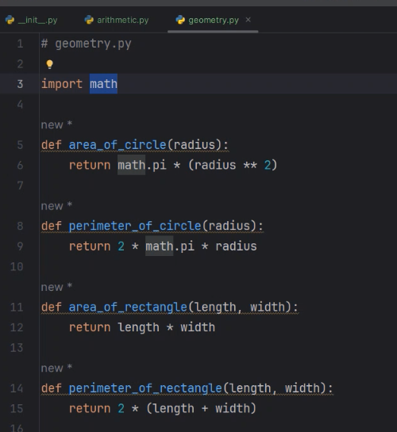

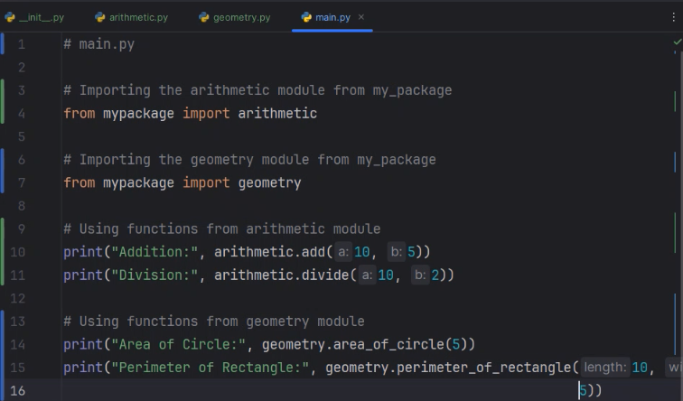

* Package is the collection of modules
* Modules contain the random reusable methods

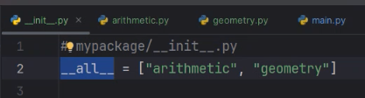

* We can use the above all command in init.py of package so that we can simply use import * for importing all modules.

KEYWORD ARGUMENTS

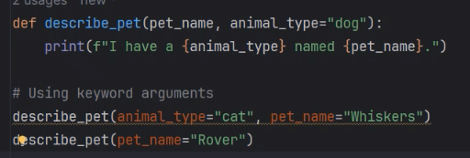

* If we want to change the order of giving arguments then we can use key word arguments
* If we don’t give value for parameters it will take the default argument

ARBITARY ARGUMENTS

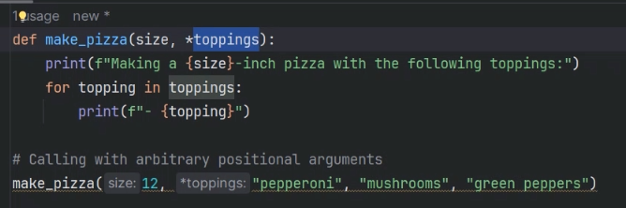

Tuples are inserted

ARBITARY KEYWORD ARGUMENTS

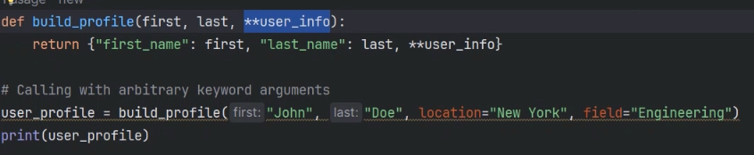

Dictionary inserted

**NUMPY**

* It is used for mathematical operations

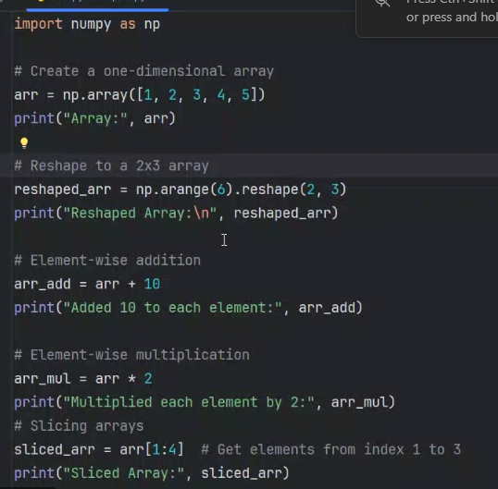

DATA CLEANING

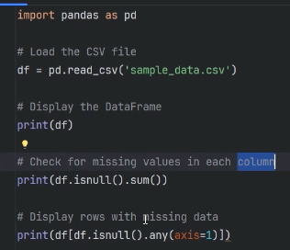

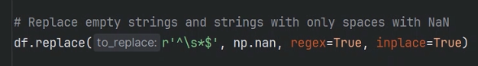

* The above given code using numpy will change the empty space to a NaN(Not a Number or Null)
* In above “^” means starts with \s(space) if it starts with space it will change it to a Nan
* Regex means regular expression ,inplace means it will take the same place

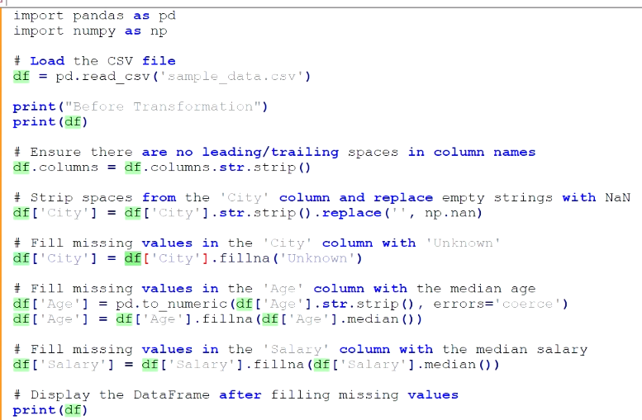

MERGING AND TRANSFORMING DATA

